025:250 COMPOSITION: ELECTRONIC MEDIA I
Fall 2010
Assignment 2, Part 2, to be presented in class Oct. 4-6.

1. Overview
a. In Part 1, the sound-classes from Assignment 1 were reversed, transposed by + and - 1-2 semitones, transposed
down to 3 different low frequency registers, and up to 3 different high frequency registers.
b. The total number of sound-classes will be between 300 and 600, depending on how many sound-classes were
created in Assignment 1 and how many reversed versions of these were not discarded.
c. In Part 2, a relatively small number of these 300-600 sound-classes will be used in Pro Tools to make 10-15
sound-objects, as described below.

2. In Pro Tools, do the following:
a. Create a new session at 44.1/16, if this was the format of your sound-classes.
b. Create 10 mono tracks.
c. Set the track height for all of these at medium height.
d. Set the volume automation to approximately-10db, as discussed in class.
e. Set the pan automation to somewhere between 60> on the left and <60 on the right, as discussed in
class.
f. Import all of the 300-600 sound-classes, using the drag and drop method explained in class.

3. Create a sound-object as shown below.
a. Find a sound-class that has more substance and complexity than others. This will be the dominant sound-class.
b. Drag the dominant sound into the edit window in one of the upper tracks and near the beginning, but not
exactly, of the session.
c. Find a sound-class that will complement the attack of the dominant sound. This will be the attack.
d. Drag the attack into a lower track than the dominant and to its left.
e. Find a sound-class that will complement the end of the dominant sound. This will be the tail.
f. Drag the tails into a track lower than the attack track and placed near the end of the dominant sound.
g. The edit window will resemble one below:
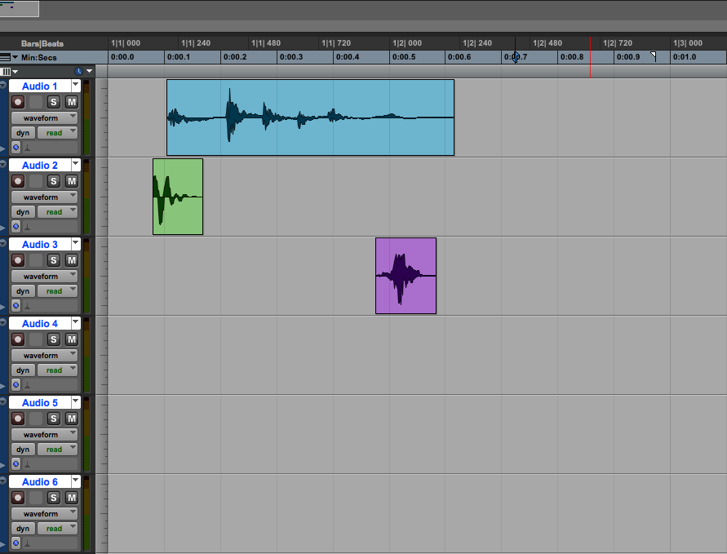

h. Use the volume automation as needed, as shown below:
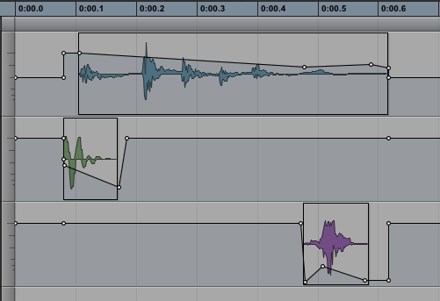

4. The following techniques may be useful.
a. Pan the sounds to create depth, placement, and movement.
b. Discussion about panning.
c. Try plug-ins in EQ and pitch shift.
d. Discussion about delay and reverb.
e. Bounce the sounds into a stereo file.
f. This file is called a sound-object in this class.
g. The naming scheme is discussed below.

5. Every sound-object will be named by a series of 5 symbols: a capital letter, the number 1 or 2, again the number 1 or 2, the plus or minus sign, again the plus or minus sign. Some examples are: A21+- , B11-- , and A11-+ . The meaning of these symbols is explained below.

6. Ignoring the capital letter for the moment, we begin with the numbers 1 and 2.
a. 11 = 1 sound-class used for the attack and 1 sound-class for the tail.
b. 21 = 2 sound-classes used for the attack and 1 sound-class for the tail.
c. 12 = 1 sound-class used for the attack and 2 sound-classes for the tail.
d. 22 = 2 sound-classes used for the attack and 2 sound-classes used for the tail.
e. Shown below is an example of a sound-object named A21++.
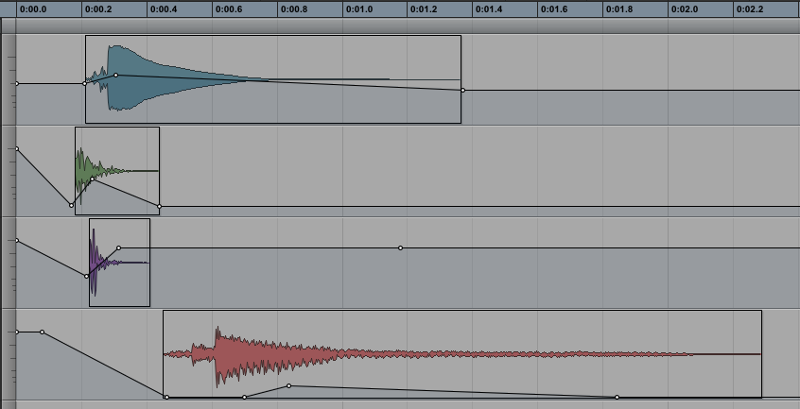
Note: the number 2 in the name refers to the two attacks, while the number 1 refers to the one tail.

7. The symbols + and – are explained below.
a. ++ = attack(s) and tail(s) are audible.
b. -- = attack(s) and tail(s) are sub-audible.
c. +- = attack(s) are audible and tail(s) are sub-audibleaudible.
d. -+ = attack(s) are not audible and tail(s) are audible.
e. Shown below is an example of a sound-object named A21-+.
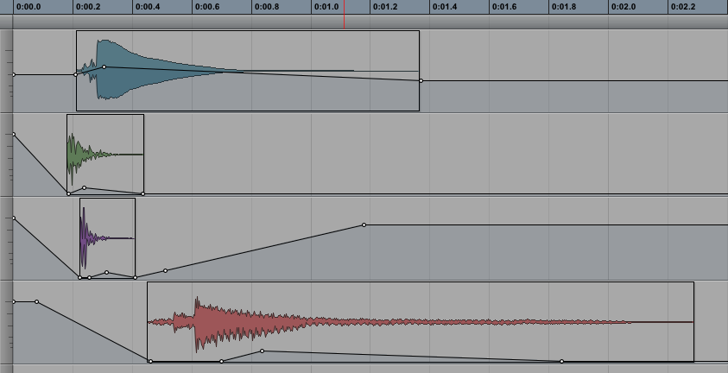
Note: minus sign - in the name indicates that the two attacks are sub-audible, while the plus sign + indicates that
the tail is audible.
8. The capital letter at the beginning of a file name is used only to keep track of a composer’s work in creating sound-
objects. For Assignment 2, every combination of 1, 2, +, - will be used. The letter A precedes every unique instance of these symbols, as shown below:

A11++ A21++ A12++ A22++ B11++ B21++
A11-- A21-- A12-- A22-- B11-- B21--
A11+- A21+- A12-- A22-- B11+- B21+-
A11-+ A21+- A12+- A22+- B11-+ B21+-

The first 16 combinations are denoted by the letter A. The second set of combinations are denoted by the
letter B. These letters help you keep track of how many times a particular combination has been used. Note that
the letters have no aural meaning. Thus, for example, the A combinations do not share a certain kind of sound or
structure that differentiates them from B combinations.

9. PhD and Masters’ and Undergrad students have different requirements for completing Assignment 2. The PhD students should create 24 sound-objects shown in the table above in Step 8. Masters’ and Undergrad students should create the 16 sound-objects beginning with the letter A.

10. Bouncing and saving sound-objects will be discussed in class.

11. The purpose of Assignment is detailed below.
a. Within the very small and local world on the sound-object, there is a very big distinction between sounds with
different numbers of attacks and tails, and whether these are audible or sub-audible. It is important the
composers learn to zero in these kinds of small variations in sound and learn to hear them.
b. Composers working in the electronic medium need to keep the larger picture in mind. Among other things, this
means that such nuances as the audibility and complexity of attacks and tails are controlled in a higher level of
the composition. For example, a passage of sound-objects such as A21++ , A12++, A22++, … will sound
much different from a passage of sound-objects such as A11-+ , A11-- , A11+-, …
c. Learning to work with naming schemes like these is a good preparation leading to work in Max/MSP in which
sounds are controlled symbolically.

12. Although the assignments will not be presented in class until Oct. 4-6, students are encouraged to bring in
examples of their work so that we all can learn how to hear better at very nuanced levels.

13. If, when working on a sound-object, the material suggests things to you that are not part of the assignment, go
ahead and pursue that direction and give it a name such as Z1, Z2, LF1a, LF1b, …PizzAa, Pizz Ab,…

